Progress Report -2

## Date – 19 November 2017

## Project name – Portable Music Player

## Reporting Period – From 12 November 2017 To 19 November 2017

## Authors:

### IMT2016096 Atibhi Agrawal

### IMT2016104 Sai Prakash

### IMT2016124 Akash Sharma

### IMT2016126 Tanishq Gupta

### IMT2016128 Kartik Gupta

## Summary

We aim to create a portable and affordable music tool for everyone. As our tool is motion controlled, the user need not the nuances and technicalities of music.

Working:

* Altering the distance between the hands will change the pitch.
* Changing the orientation will vary the amplitude.
* Cutoff frequency of digital low pass filter will also be varied.
* There will be different modes of operation that can be accessed with the help of a button.

# Introduction

We thought of this because we wanted to make something fun that can be used by the common man, kids for educational as well as recreational purposes.

We hope to implement four different modes of operations. They are :

**1. Continuous mode**: 2 octave range (C4 - C6), chromatic scale with 8 increments between each half step.

**2. Chromatic 2oct mode:** 2 octave range (C4 - C6), chromatic scale.

**3. Chromatic 1oct mode**: 1 octave range (easier to play) (C4 - C5), chromatic scale.

**4. Major mode:** 2 octave range (Bb3 - Bb5), Bb major scale.

This project requires a good deal of hardware and significant sofware .

# Project Work completed in Report - 1

* Working of Ultrasonic Transducer understood and implemented.
* Working of Accelerometer i.e. MPU6050 understood and implemented.

# Project Work completed in Report – 2

# We spent most of our time this week researching on how to produce sound waves based on the changes in our hand gestures and understood the project completely.

# Brief summary of the research we did :

Hand gestures supported by our project

* Movement in X direction
* Rotation in X direction
* Rotation in Y direction

## Movement in X direction

This movement will be read by the ultrasonic transducers. It will give us the distance between our hands. Let the distance be ‘x’.

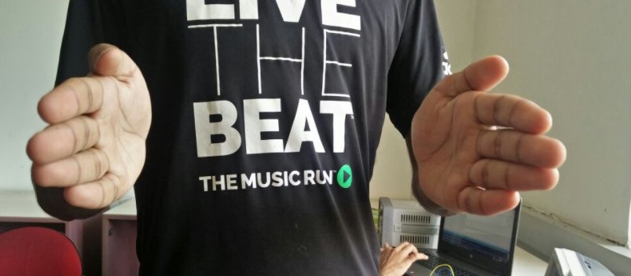

## Rotation in Y direction

This movement will be read by 3 axis accelerometer. It will give us Accelerations in x , y and z axis. Those accelerations are basically components of gravity in all the axis. Let us define them as ‘Ax’, ‘Ay’, ‘Az’.

When close to the body

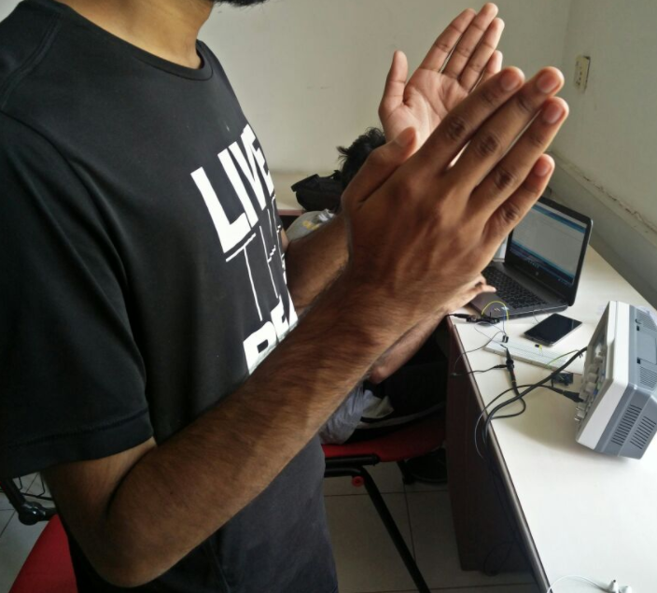

when away from the body

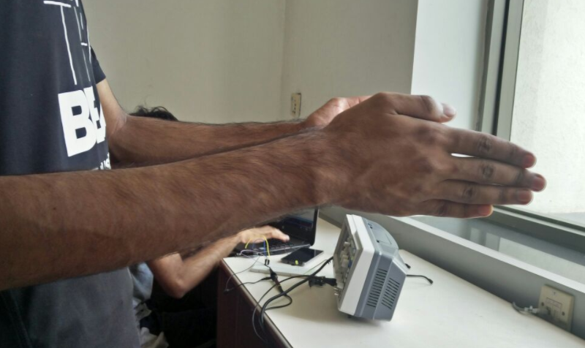

## Rotation in X direction

This movement will be also read by the 3 axis accelerometer.

Rotated upwards

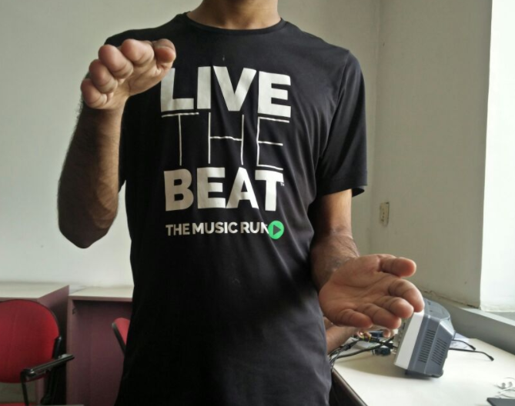

when not rotated

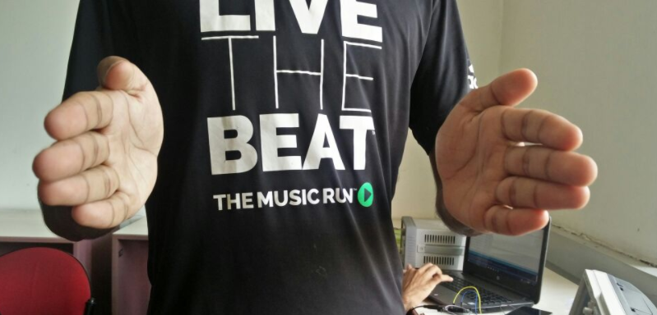

rotated downwards

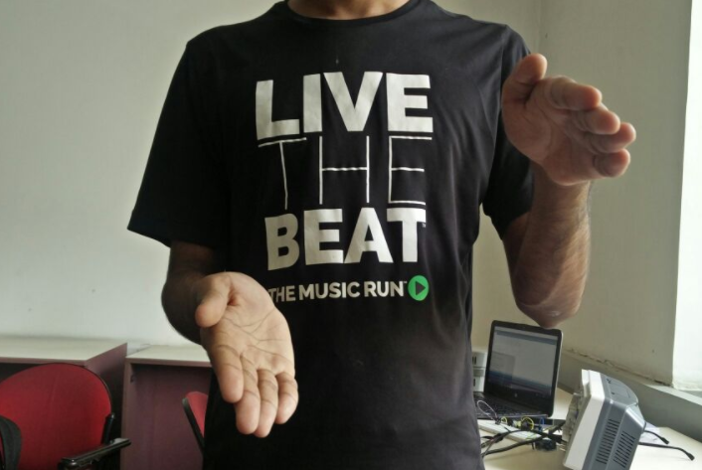

So now we have 4 inputs x, Ax, Ay, Az.

Now we will write functions to generate frequency and amplitude for the sound waves. These functions will be based on the mode selected.

For example. If we choose mode 1 i.e. 2 octave range (C4 - C6), chromatic scale with 8 increments between each half step . our max distance will give us frequency for the C note in 4th octave and as we will reduce the distance frequency will increase based on a mathematical formula.

Similarly if you have your hands close to your body amplitude will be minimum and as you will move them away amplitude will increase.

Therefore , for our sound wave

Frequency, f = F(x)

Amplitude , A = F(Ax , Ay , Az)

Now we will generate sine wave through Arduino [ A sin ((2 * pi * f )* t) ].

We will pass this sound wave through our low pass filter.

The cut off frequency for our notes will be given by the rotation in x direction. As we will rotate our hands in anticlockwise direction cut off frequency will increase allowing us to produce shriller sounds (higher octaves) and as we will rotate in clockwise direction cut off frequency will decrease giving us softer sounds(lower octaves).

Then we will pass this wave to the 3.5 mm audio jack of our speakers.

Also we generated the sine wave for a specific frequency and amplitude. Though generating sine waves with freuqency and amplitude

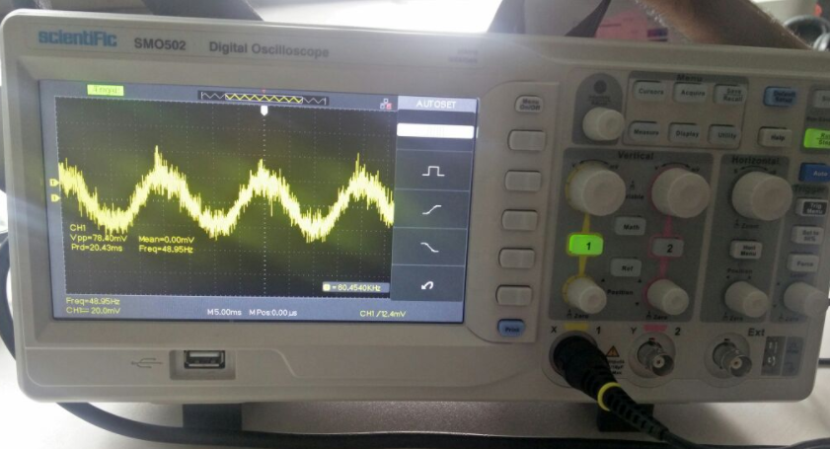

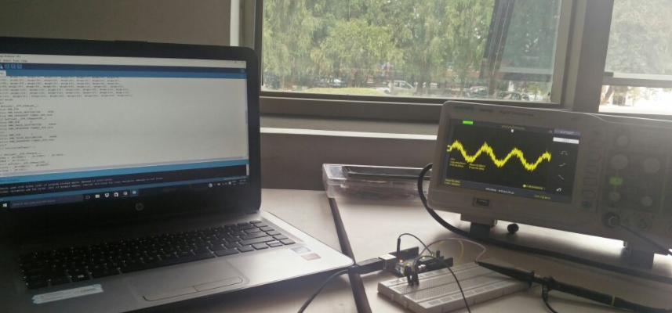

# Project Related Issues

# Generating sine wave with frequency and amplitude as inputs through coding.

# Updates on Budget

* We would like to add the 3.5mm audio jack input to our budjet.

# Till next reporting

We will write the code for our project and will assemble all the hardware we have setup till now and will be ready for the demonstration.